**EKG Exam**

**Part 1: Understanding EKG Complexes**

1. What wave form of the EKG complex represents the AV Node?
   1. P wave form
   2. ORS wave form
   3. ST wave form

2 What is considered the pacemaker of the heart?

a. SA Node

b. AV node

c. Bundle of His

1. What is the isoelectric line?
   1. Horizontal lines on the EKG graph paper
   2. Baseline of the EKG
   3. The section between the P wave and QRS wave
2. Looking at the EKG graph paper, how many blocks would you see for 16 seconds?
   1. 6 small blocks
   2. 5 small blocks
   3. 4 small blocks
3. The right bundle branch is one step ahead of the left bundle branch when sending the message (electrical conductions) to the villagers?
   1. True
   2. False

**Exam Continues onto Next Page**

**Part 2: EKG Complex Exam**

The following EKG strips are snapshots from longer strips. Your goal is to focus on the EKG complex itself. Then answer the questions listed below each strip.

[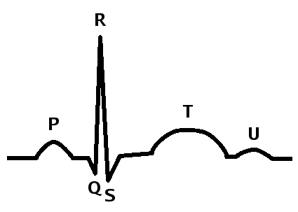](https://www.boundless.com/physiology/textbooks/boundless-anatomy-and-physiology-textbook/cardiovascular-system-the-heart-18/physiology-of-the-heart-175/electrocardiogram-and-correlation-of-ecg-waves-with-systole-877-10099/images/systole-qrs-complex/)1. Label the correct waveforms

d

a.__________

b.__________

e

a

c.__________

f

d.__________

b

e.__________

c

f.__________

.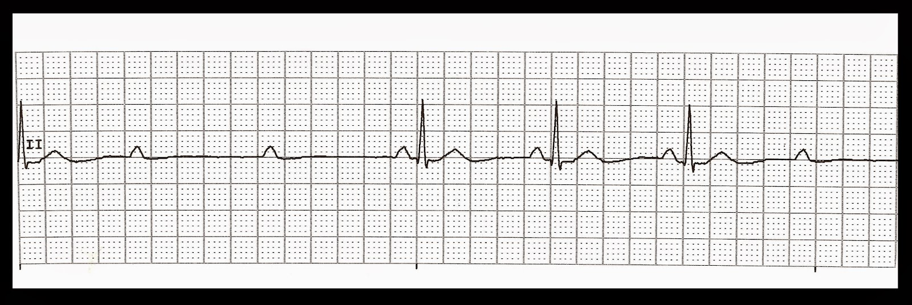

2. What is the PRI? __________ Is the PRI normal? Yes No

What is the width of the QRS complex? __________ Is this normal? Yes No

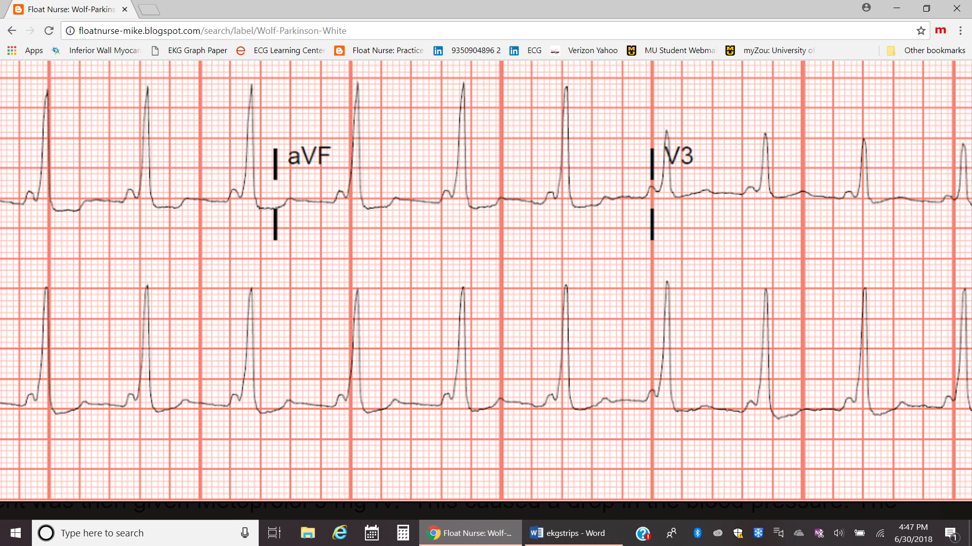

3. What is the PRI? __________ Is the PRI normal? Yes No

What do you notice about the PRI? _____________________________________________________

**Exam Continues onto Next Page**

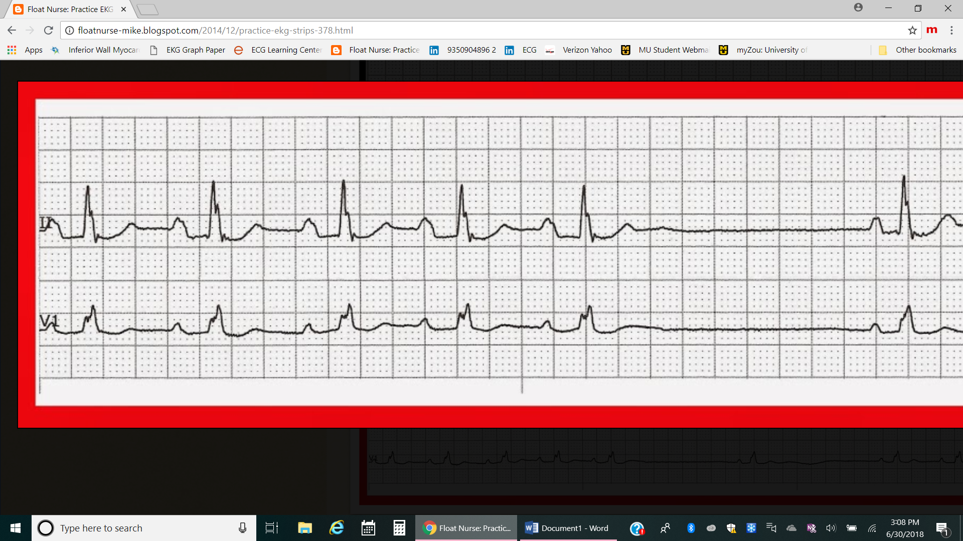

4. What is the PRI? __________ Is the PRI normal? Yes No What is the QRS complex? _________

What do you notice about the QRS complex? ________________________________________________

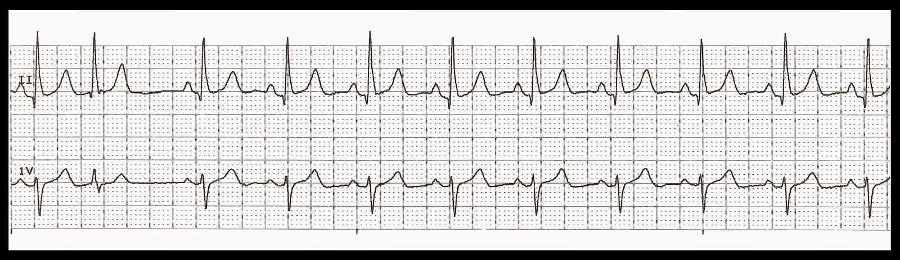

5. What is the PRI__________ Is the PRI normal? Yes No

What is the QT interval __________ Is this normal? Yes No

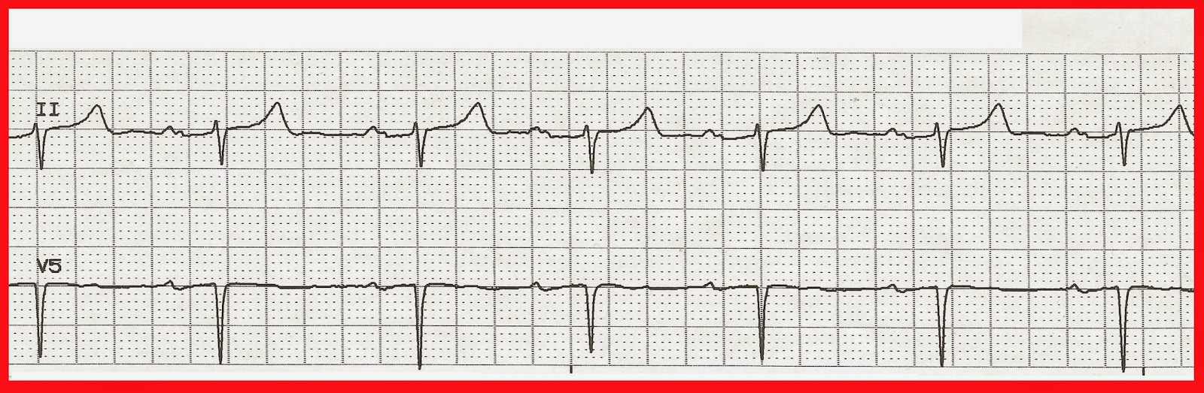

6. What is the PRI? __________ IS the PRI normal? Yes No

What is the QRS Complex? _________

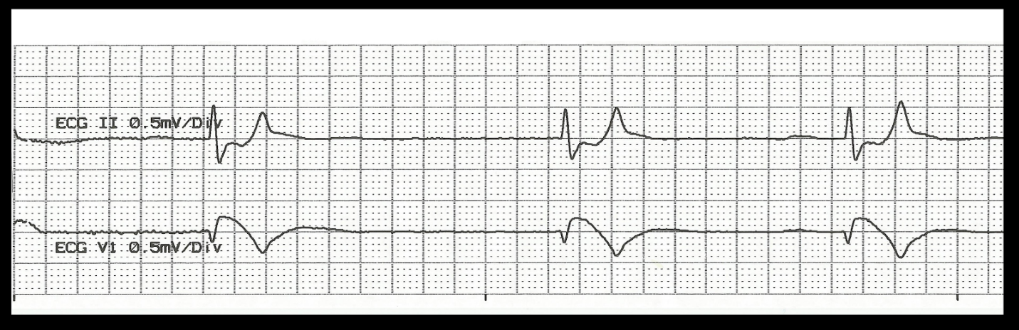

BONUS Question (worth 2 points)

What is missing? _______________________________________________________________________

**End of Exam**